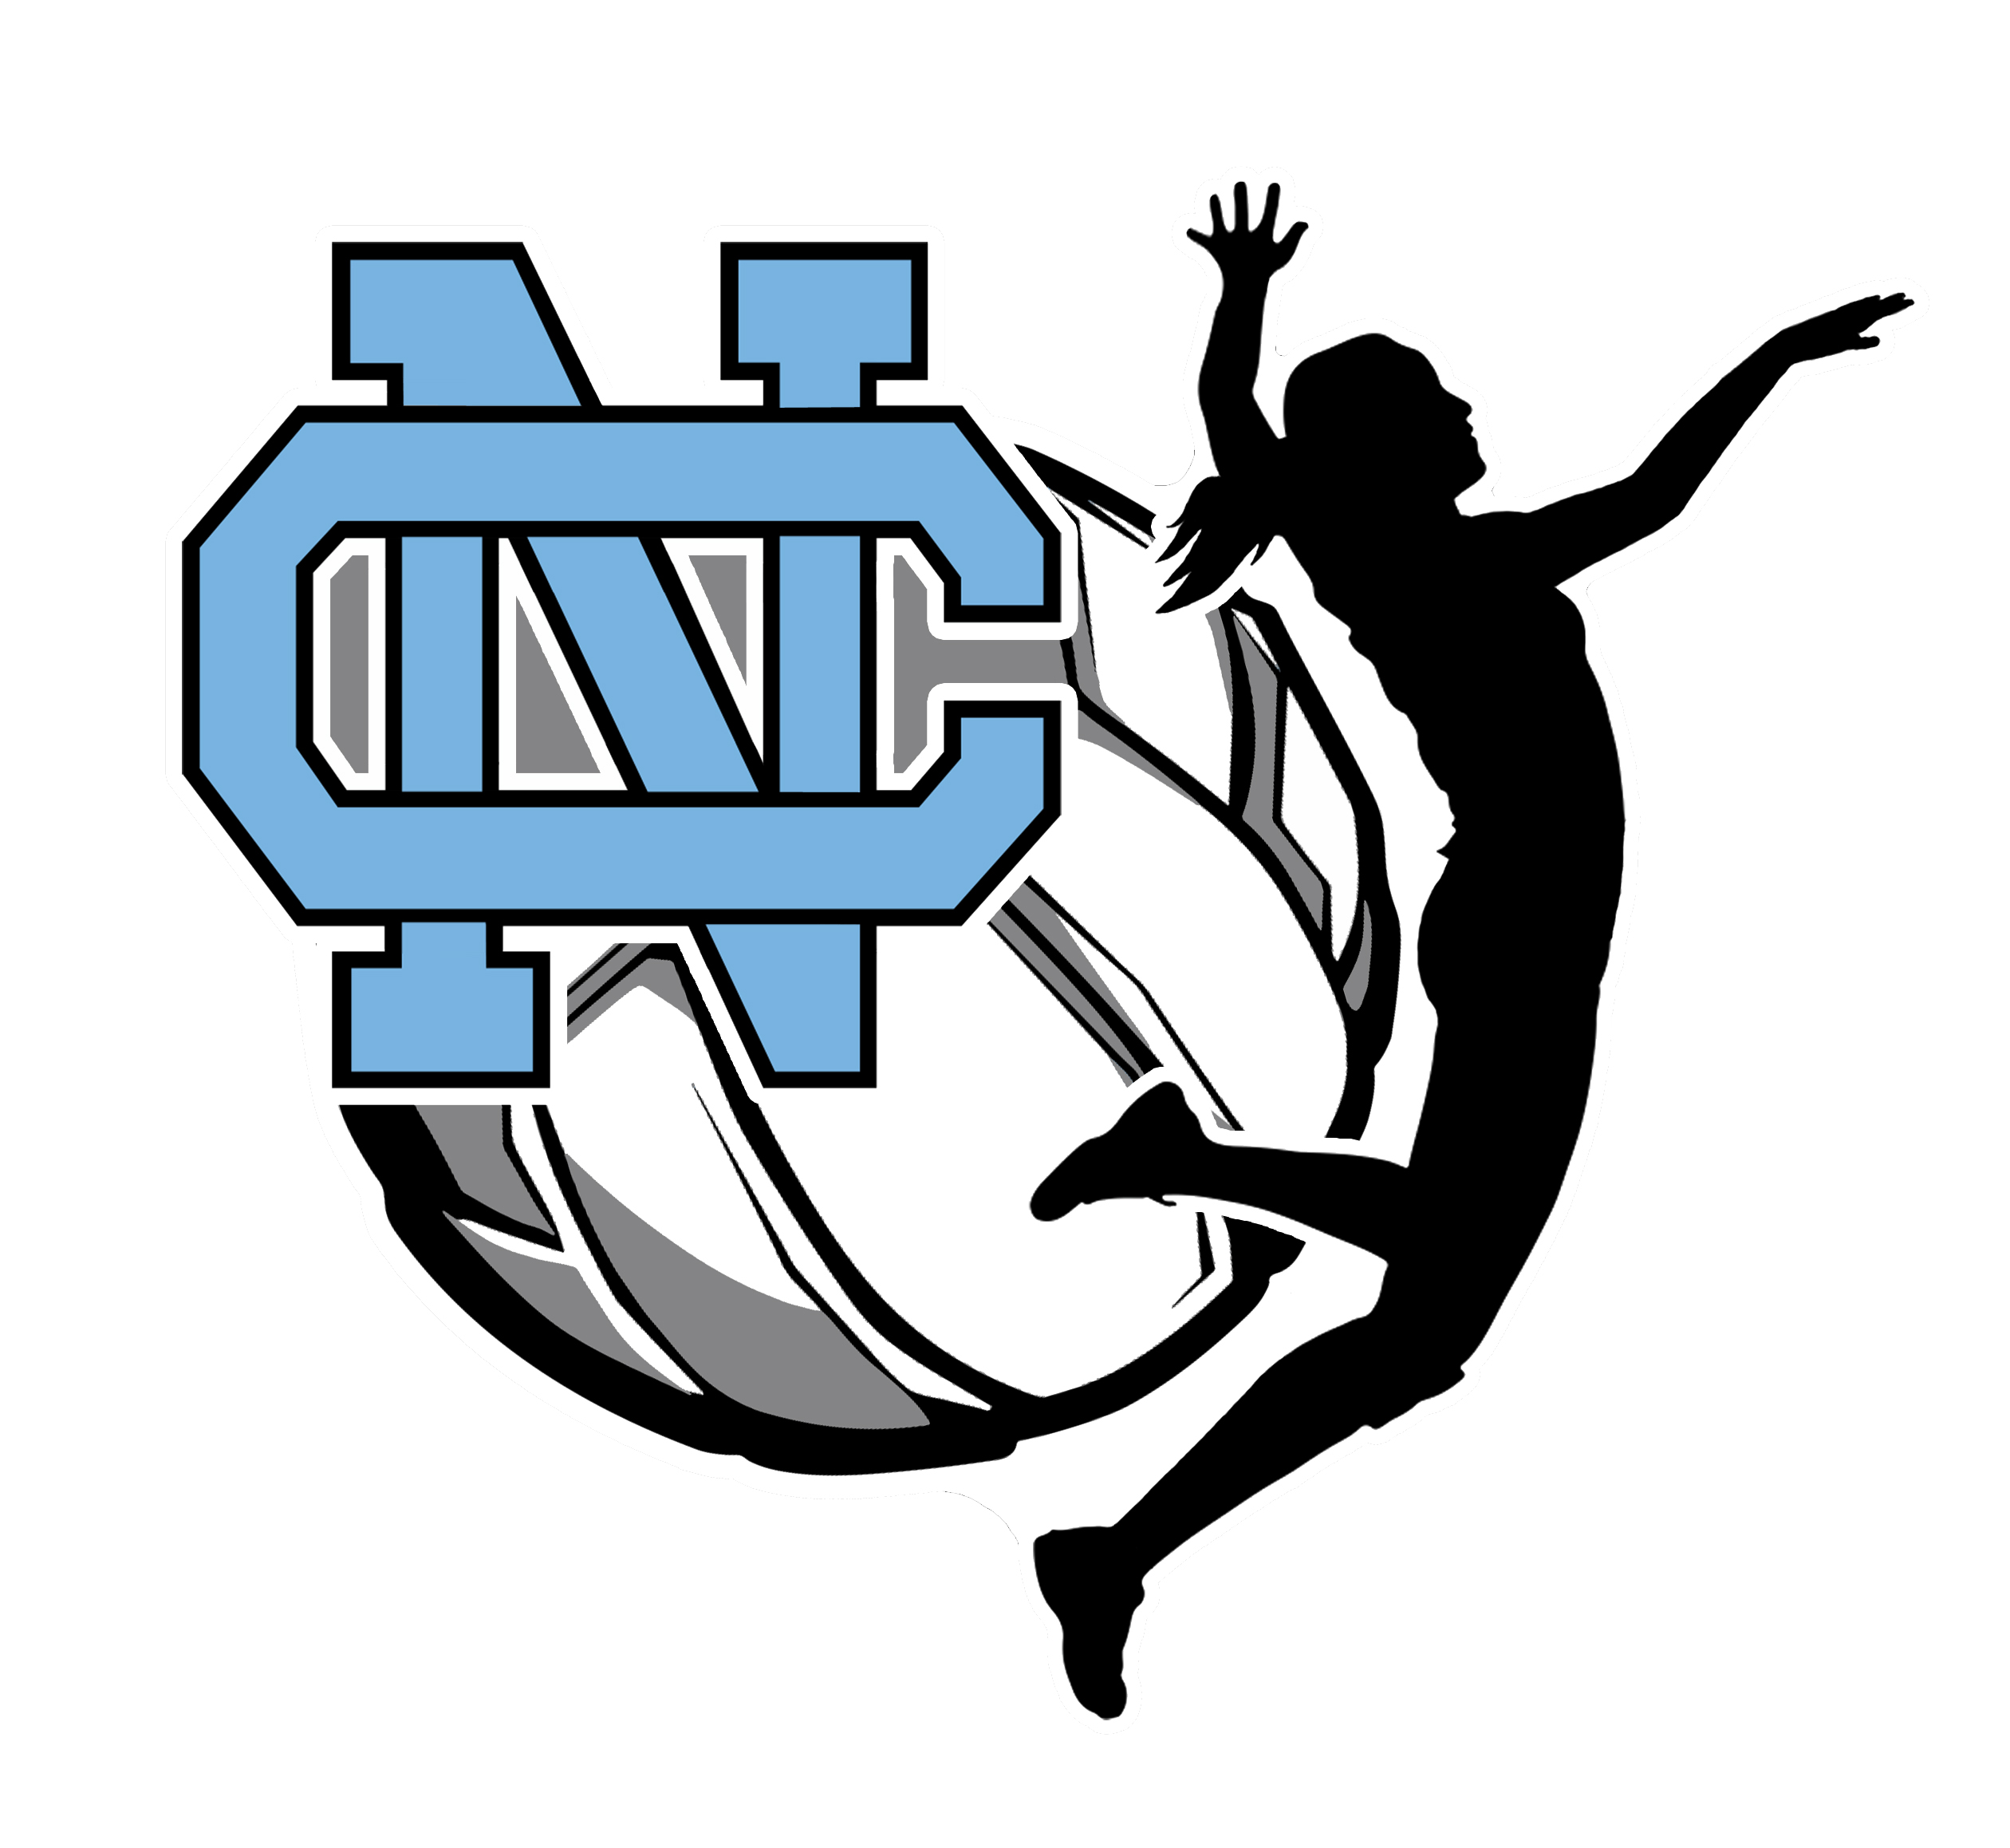Clovis North Girls’ Volleyball

TO: Parents, Family, Friends and Business Partners

The Clovis North Bronco Volleyball team is requesting your support. As you may be aware, the budget provided by the state to Clovis Unified does not fully fund our Volleyball program. We are asking for your assistance in raising funds for the volleyball program. These funds will be used in many ways including, but not limited to:

- Maintenance and upgrading of Volleyball equipment
- Uniforms for players at all levels
- Travel and Lodging for teams to participate in out of town tournaments
- End of season awards, senior recognition and program dinner

There are a few programs we are using to raise funds:
- Bronco Stampede: Date Sept. 23rd 2017 (See website www.clovisnorthgirlsvolleyball.weebly.com)
- Program Ad Sales: Deadline August 11th 2017 (See related form)
- Individual Sponsor: Deadline Sept 1st 2017 (Use this form)

Your donation is not mandatory. Our girls’ program fundraising goal is a team objective. Each player is asked to participate in some way to two of the three fund raising activities to help us support the program.

We would like to thank you in advance for your sponsorship of our program.

Yes, I would like to become an individual sponsor of the Clovis North Girls Volleyball program. Enclosed is my tax-deductible donation for:

( )$20 ( )$50 ( )$75 ( )$100 ( )$250 ( ) Other $______________

Make checks payable to: Clovis North Girls Volleyball.

Please turn in any donations directly to Coach Herb or mail to the school at

Clovis North
Girls Volleyball
2770 E. International
Fresno CA 93730

If you have any questions please email Coach Herb at travisherb@cusd.com.

Thank you for your support of Bronco Volleyball!

501(c)(3) Tax ID #711036638
Please keep a copy of this form, along with your cancelled check, for your tax records.

